Evidence Questions (4) on JavaScript

*IDB-BISEW IT Scholarship Project*

*Batch ID: WDPF/TCLD-A/47/01*

*Instructor Name: Syed Ziaul Habib*

1. Create an html file named **billing.html** with the form below:

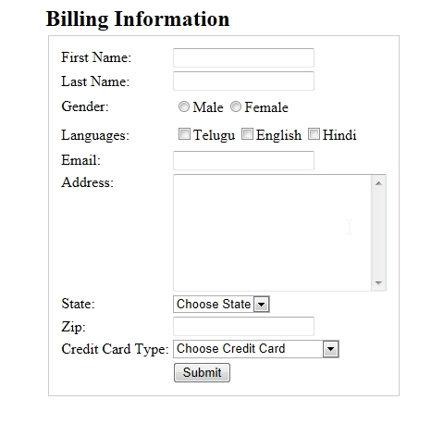

Write Script with required functions to show data in a formatted way in a new window when user click submit button filling the form.

1. Write an html document to find factorial of a given number (n!) where the number is taken from user. Save in a file named factorial.html

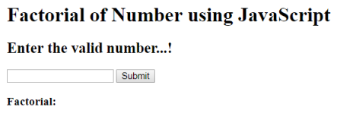

1. Find whether a number is prime or not. User will give the number. Save in a file named checkPrime.html

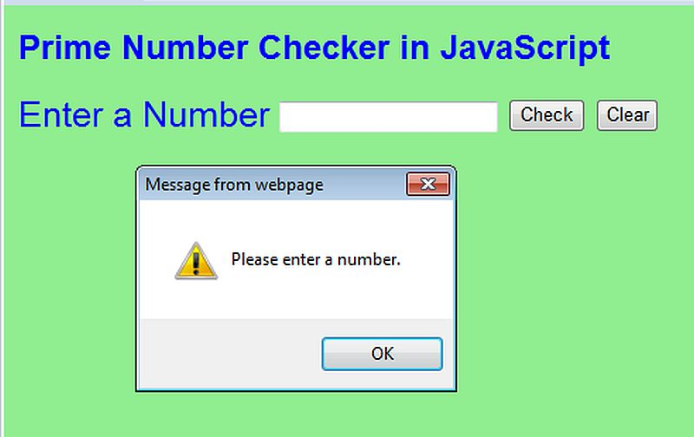

1. Using JavaScript stores five students name in an array. Make them all uppercase then print the student’s name in ordered list. Save in a file named studentList.html